General Information
- Use this process if the taxpayer received lump sum social security benefits or RR Benefits Tier 1 for previous years. Do not do an amended return.
- The amounts are shown on Form SSA-1099A, Box 3 (Bottom).
- Complete this process after all income is entered.
- You must have copies of prior year’s returns.
- If the taxpayer’s total SS or RR Benefit is not taxable in the current year, STOP HERE.

What you need to know from previous year’s returns
- Filing Status from prior year
- The amount of SS or RR received for the prior year
- The taxable portion of the SS or RR from the prior year
- Adjusted Gross Income from prior year
- The total of any exclusions/adjustments you claimed in the earlier year for
  - Student loan interest (Form 1040, page 1, or Form 1040A, page 1)
  - Tuition and fees (Form 1040, page 1, or Form 1040A, page 1)
  - Domestic production activities (for 2005 through 2014) (Form 1040, page 1)
  - Foreign earned income or housing (Form 2555 or Form 2555-EZ)
  - Certain income of bona fide residents of American Samoa (Form 4563) or Puerto Rico
  - Adoption benefits (Form 8839)
  - Qualified U.S. savings bond interest (Form 8815)
- The amount of any tax-exempt interest from the prior year

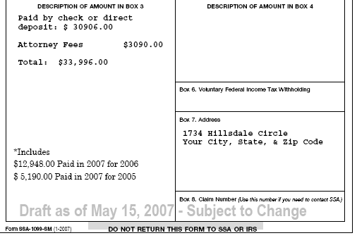
Amounts from previous years are shown in Box 3 of the SSS-1099
2016 for 2014
2016 for 2013

References
- IRS Publication 4012 – Page D-27 and D-28

- IRS Publication 915

Start with Social Security Input Screen

Step 1
- Enter the information from the SSA-1099 for both taxpayer and spouse into the TSO Social Security 1099 SSA screen as normal. Make a note of the refund/owed amount in the TSO refund monitor for both the Federal and NJ.

Step 2
- Select “Begin Worksheet” at the bottom of the Social Security Input Screen.

Step 3
- Create a worksheet for each year a lump sum was paid. See screen shot below from Pub 4012 page D-26.

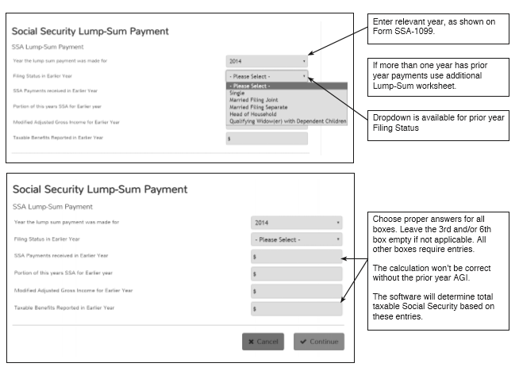
Modified AGI = AGI (1040 line 37 + tax exempt interest (1040 line 8b) + student loan interest deductions (1040 line 33) + Tuition & Fees deduction (1040 line 34) + any exclusions or adjustments on Forms 8815, 8839, 2555, 2555EZ.

Step 4
- After completing the Lump Sum Social Security Worksheets, check the refund/owed amount in the TSO refund monitors. Compare the total of the Federal and the NJ refunds with the total noted in Step 1.
- Leave the lump sum worksheets in the return even if there is no benefit in case there is a future amendment to the return.

Legal Fees
Legal fees are deductible on Schedule A, line 23 (subject to the 2% AGI limitation), if the taxpayer itemizes deductions. Legal fees associated with obtaining the benefits can be deducted to the extent that the benefits are taxable.
Example:
Attorney Fees: $3,090
Gross SS Income: $33,996
Taxable amount of SS: $23,925
Deductible attorney fees (Schedule A, line 23): [$3,090 x $23,925 / $33,996] = $2,175
NOTE: Since previous returns were not amended, the entire $23,925 was allocated to the current year.
Disability Insurance Repayment
Social Security Lump Sums are often associated with repayment of private disability insurance. The "repayment" can be handled according to IRC 1341 as a "Claim of Right", in a manner similar to the SS Lump Sum Election. This is “out of scope” and should be referred to a professional preparer.

